Spring JDBC

* mechanism to connect with database and execute sql queries.
* Uses internally JDBC API
* Reduces lot of problems raised by JDBC API

Problems of JDBC API

1. Need to write lot of code before and after executing the query. Operations like
   1. Creating connection object,
   2. creating statement object
   3. closing result set object
   4. closing connection object
2. Need to handle the exception while executing database logic
3. Handle the transaction explicitly

Spring JDBC is perfect solution to overcome all problems mentioned above.

Spring JDBC is implemented using several approaches given below:

* JdbcTemplate
* NamedParameterJdbcTemplate
* SimpleJdbcTemplate
* SimpleJdbcInsert and SimpleJdbcCall

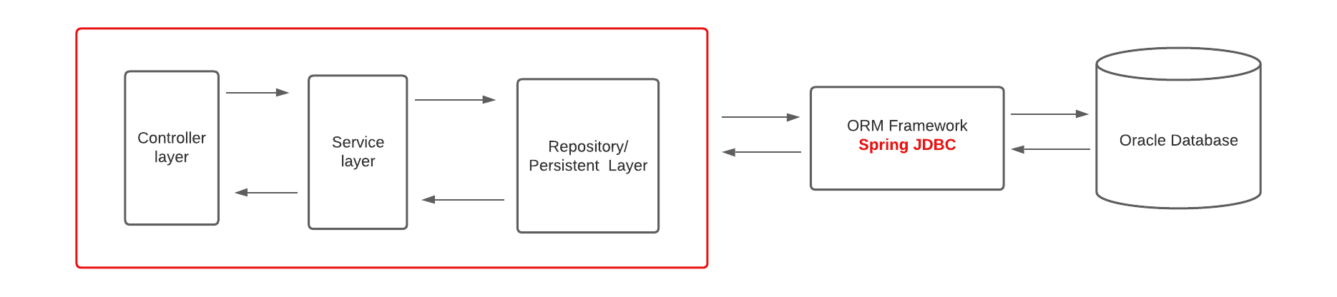

**Approach 1: JDBCTemplate**

* Creation and release of resources such as creating and closing of connection object etc. will be taken care by itself. So it will not lead to any problem if you forget to close the connection.
* Handles the exception and provides the informative exception messages by the help of excepion classes defined in the **org.springframework.dao** package.
* Used to perform all the database operations by the help of JdbcTemplate class such as insertion, updation, deletion and retrieval of the data from the database.

**Methods used in JDBCTemplate class**

1. **public int update(String query): :** used for inserting, updating or deleting records in database
2. **public int update(String query, Object …args):** used for inserting, updating or deleting records in database using PreparedStatement using given arguments
3. **public void execute(String query):** is used to execute DDL query. (Create, alter, drop table)
4. **public T execute(String query, PreparedStatementCallBack action):** executes the query by using PreparedStatement callback.
5. **public T query(String query, ResultSetExtractor rs):** is used to fetch records using ResultSetExtractor.
6. **public List query(String query, RowMapper rm):** is used to fetch records using RowMapper.

**Implementation of Spring JDBC with Spring Boot (Spring Boot JDBC)**

1. add spring-data-jdbc starter in pom.xml file
2. create a repo class and autowire JdbcTemplate class in it